Software Requirements Specification
for
TimeTracker 2.0
Version 0.3
Prepared by Sarah Mercier
Strictly Business
9/2/10
Table of Contents
Table of Contents 1
Revision History 3
1. Sign-offs 4
2. Introduction 5
2.1 Purpose 5
2.2 Document Conventions 5
2.3 Intended Audience and Reading Suggestions 5
2.4 Project Scope 5
2.5 References 5
3. Overall Description 5
3.1 Product Perspective 5
3.2 Product Features 6
3.3 User Classes and Characteristics 7
3.4 Operating Environment 8
3.5 Design and Implementation Constraints 8
3.6 User Documentation 8
3.7 Assumptions and Dependencies 9
4. System Features 9
4.1 Data and application hosting on Google Apps 9
4.1.1 Description and Priority 9
4.1.2 Stimulus/Response Sequences 9
4.1.3 Functional Requirements 9
4.2 Log and submit time spent on projects and clients 9
4.2.1 Description and Priority 9
4.2.2 Stimulus/Response Sequences 9
4.2.3 Functional Requirements 10
4.3 Manage leave time 10
4.3.1 Description and Priority 10
4.3.2 Stimulus/Response Sequences 10
4.3.3 Functional Requirements 11
4.4 Generate, print, and export reports 11
4.4.1 Description and Priority 11
4.4.2 Stimulus/Response Sequences 11
4.4.3 Functional Requirements 11
4.5 Employee management 12
4.5.1 Description and Priority 12
4.5.2 Stimulus/Response Sequences 12
4.5.3 Functional Requirements 12
4.6 Time approval and rejection with notification 13
4.6.1 Description and Priority 13
4.6.2 Stimulus/Response Sequences 13
4.6.3 Functional Requirements 13
4.7 Integration of Google Calendar, Mail and Talk 14
4.7.1 Description and Priority 14
4.7.2 Stimulus/Response Sequences 14
4.7.3 Functional Requirements 15
4.8 Brand customization 15
4.8.1 Description and Priority 15
4.8.2 Stimulus/Response Sequences 15
4.8.3 Functional Requirements 15
4.9 Time management through Android application 16
4.9.1 Description and Priority 16
4.9.2 Stimulus/Response Sequences 16
4.9.3 Functional Requirements 16
4.10 Impersonate other users 17
4.10.1 Description and Priority 17
4.10.2 Stimulus/Response Sequences 17
4.10.3 Functional Requirements 17
4.11 Project/Client management 17
4.11.1 Description and Priority 17
4.11.2 Stimulus/Response Sequences 18
4.11.3 Functional Requirements 18
5. External Interface Requirements 19
5.1 User Interfaces 19
5.2 Hardware Interfaces 19
5.3 Software Interfaces 19
5.4 Communications Interfaces 19
6. Other Nonfunctional Requirements 19
6.1 Performance Requirements 19
6.2 Safety Requirements 20
6.3 Security Requirements 20
6.4 Software Quality Attributes 20
Appendix A: Glossary 20
Appendix B: Analysis Models 20
Appendix C: Issues List 20

Revision History
Name | Date | Reason For Changes | Version
Sarah Mercier | 8/26/10 | Began initial release. | 0.1
Sarah Mercier | 8/31/10 | Finished initial release minus glossary, appendices and diagrams. | 0.2
Sarah Mercier | 9/2/10 | Added diagrams and Impersonate Other Users feature for Administrators and Project Managers. | 0.3

Sign-offs

I agree that this document represents our best understanding of the requirements for this project today and the system described will satisfy our needs. I agree to make future changes in this baseline through the project’s defined change process. I realize that approved changes might require us to negotiate the cost, resources, and schedule commitments for this project.

________________ _______________ ______________ _______________
Name Title Signature Date

________________ _______________ ______________ _______________
Name Title Signature Date

________________ _______________ ______________ _______________
Name Title Signature Date

________________ _______________ ______________ _______________
Name Title Signature Date

Introduction

Purpose
This SRS describes the software functional and nonfunctional requirements for TimeTracker 2.0. TimeTracker 2.0 will permit users to manage timesheets and leave time online and generate, print or export corresponding reports related to that data.

Document Conventions
No document conventions are being used at this time.

Intended Audience and Reading Suggestions
This document is intended to be used by members of the project team that will implement and verify the correct functioning of the system.

Project Scope
TimeTracker 2.0 is a web-based application that will allow users to manage their timesheets and leave through an intuitive, easy-to-use interface. It will have a corresponding Android application. The system will also allow reports on that data to be easily generated, printed or exported. A detailed description of the project scope can be found in TimeTracker 2.0 Vision and Scope.

References
- Mercier, Sarah. TimeTracker 2.0 Use Case Document.
- Mercier, Sarah. TimeTracker 2.0 Vision and Scope Document. Version 0.2. August 31, 2010.

Overall Description

Product Perspective
TimeTracker 2.0 is a new system that replaces the current system hosted on Strictly Business servers for managing timesheets and leave time. The context diagram in Figure 1 illustrates the external entities and system interfaces. The system is expected to evolve over at least three releases, ultimately allowing for complete streamlining of the payroll process, mobile phone support and other features specified more clearly in TimeTracker 2.0 Vision and Scope.

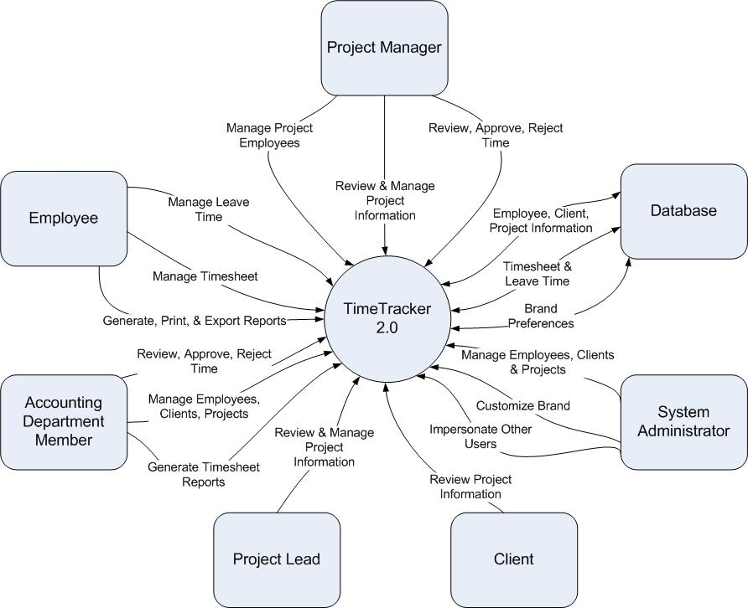
Figure 1
Context diagram for TimeTracker 2.0.
Note: Project Manager, Project Lead, and Accounting Department Member are all specialized forms of Employee and have access to all Employee actions in addition to their own specialized actions. System Administrators have access to all actions within the system in addition to their own specialized actions.

Product Features
FE-1: Data and application hosting on Google Apps
FE-2: Log and submit time spent on projects and clients
FE-3: Manage leave time
FE-4: Generate, print and export reports
FE-5: Employee management
FE-6: Time approval and rejection with notification
FE-7: Integration of Google Calendar, Mail and Talk
FE-8: Brand customization
FE-9: Time management through Android application
FE-10: Impersonate other users
FE-11: Project/Client Management

See Figure 2 for the relationship between these features. Please note that this document covers all features. For a list of features associated with specific releases of each project, please see TimeTracker 2.0 Vision and Scope Document.

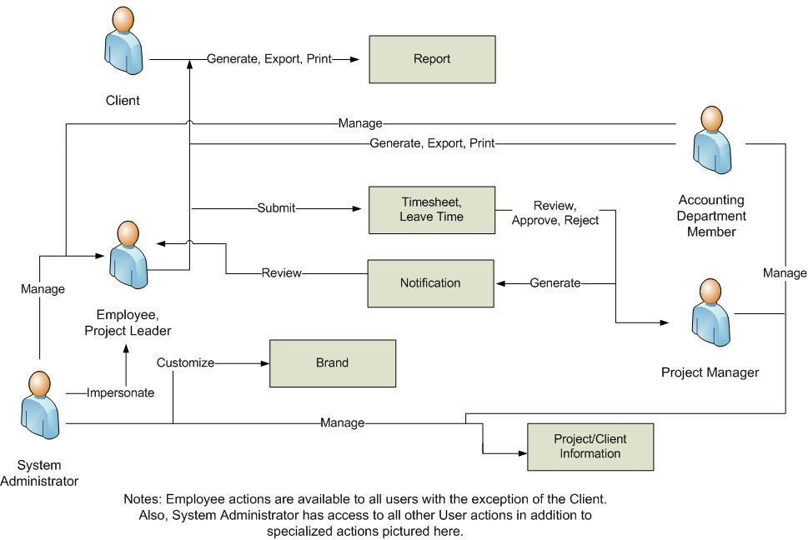
Figure 2
Major features and how they relate.

User Classes and Characteristics
Employee (favored) | The Employee is the person or people who work for the business using TimeTracker 2.0 and need to log time spent on clients/projects and manage leave. They will also use the new system to manage company email, schedule business meetings in the calendar, and communicate with other employees through instant messenger. Some might have to be trained to use the new system. Employees will have the ability to generate reports associated with their own work only.
Project Manager (favored) | A Project Manager is a special employee or group of employees which are in charge of managing a particular project. Project Managers will use the new system in the same way as a regular user, but will also need the ability to view project status and approve/reject timesheets. Project Managers will also need the ability to manage employees associated with their projects as well. Project Managers will have the ability to generate reports associated with their own work as well as the projects which they manage.
Project Lead | A Project Lead is a special employee or group of employees who are the lead on a particular project or projects. They will have the ability to approve/reject time in the event that the Project Manager is unable to do so. Project Leads, like Project Managers, will have the ability to generate reports associated with their own work as well as the projects which they are leading.
System Administrator | The Administrator is the person or people who will have any and all the privileges of all other user types. They will be able to impersonate other employees within the system. They will also have the authority to edit the branding and manage/generate reports regarding all projects/employees.
Accounting Department Member | The Accounting Department Member is the person or group of people that will be in charge of all payroll activities. They will need to have the ability to generate timesheet reports.
Client | The client is the person or people who are employing the talents of the business using TimeTracker 2.0. They will use the new system to view the remaining time and status reports associated with all their current project(s).

Operating Environment
OE-1: | System is not dependent on geographical areas.
OE-2: | System shall operate in newest versions of all web browsers.
OE-3: | There should be no constraint on users being able to access the system at a given time.
OE-4: | Data is generated by online forms and stored in the Google App Engine database.
OE-5: | Continuous service is preferred, but as long as there is no data loss, minor service interruptions can be tolerated.
OE-6: | Personal data will be stored in the database, so the Google App Engine database must be secure.
OE-7: | jQuery javascript library will be needed to create the user interface for the system.

Design and Implementation Constraints
CO-1: | All data shall be stored on Google App Engine.
CO-2: | User interface shall be composed using jQuery javascript library.

User Documentation
No user documentation information at this time.

Assumptions and Dependencies
AS-1: | No more than 500 MB of data stored on Google App Engine.
AS-2: | No more than 5 million page views monthly.
AS-3: | Users have a Google Account with which they can login.
AS-4: | Users have javascript enabled.
DE-1: | Free Google App Engine account.
DE-2: | jQuery javascript library (for user interface).

System Features

Data and application hosting on Google Apps

Description and Priority
Application will need to be hosted on Google App Engine.
Priority: high.

Stimulus/Response Sequences
Not applicable.

Functional Requirements
Not applicable.

Log and submit time spent on projects and clients

Description and Priority
Users will need to be able to log time spent on particular projects or clients along with descriptions of the activities which comprised the time spent. At the end of pay periods, users will need to submit their time for approval.
Priority: high.

Stimulus/Response Sequences
Stimulus: User requests to review time.
Response: System retrieves and displays all time logged for current time period.

Stimulus: User requests to log time.
Response: System adds time to Google App Engine database and redirects user to dashboard displaying all time logged for current pay period.

Stimulus: User requests to edit logged time
Response: System recalls from the database the information that has been saved, and fills in the data on a new form for the user to fill out.

Stimulus: User requests to duplicate logged time to a different day.
Response: System copies data from currently selected submission to selected ‘duplicate’ day.

Stimulus: User requests to submit time.
Response: System flags all time associated with the current pay period that has not already been submitted as ‘needs approval’.

Functional Requirements
Time Review | The system shall allow a user who is logged in to review their time.
Time Review Log | The system shall allow a user who is logged in to log time.
Time Review Submit | The system shall allow a user who is logged in to submit time.
Time Submit Incomplete | The system shall check to see if all required information is present, and prompt the user to fill out missing data and resubmit.
Time Submit Duplicate | The system shall copy selected time submission to new day(s).

Manage leave time

Description and Priority
Users will need to be able to manage leave time, including sick and vacation days.
Priority: high.

Stimulus/Response Sequences
Stimulus: User requests to review leave time.
Response: System retrieves and displays all leave time logged for current time period.

Stimulus: User requests to edit logged leave time
Response: System recalls from the database the information that has been saved, and fills in the data on a new form for the user to fill out.

Stimulus: User requests to duplicate logged leave time to a different day.
Response: System copies data from currently selected submission to selected ‘duplicate’ day.

Stimulus: User requests to submit leave time.
Response: System flags all time associated with the current pay period that has not already been submitted as ‘needs approval’.

Functional Requirements
Leave Time Review | The system shall allow a user who is logged in to review their leave time.
Leave Time Review Submit | The system shall allow a user who is logged in to submit leave time.
Leave Time Submit Incomplete | The system shall check to see if all required information is present, and prompt the user to fill out missing data and resubmit.
Leave Time Submit Duplicate | The system shall copy selected leave time submission to new day(s).

Generate, print, and export reports

Description and Priority
Application will need to be able to generate reports for project managers and clients as well as administrators. Clients and project managers could generate and export or print reports for their records.
Priority: medium.

Stimulus/Response Sequences
Stimulus: User requests to generate a report.
Response: System displays form containing parameters and submit button.

Stimulus: User requests to submit a report generation form.
Response: System retrieves information from database and displays report in web browser along with ‘Export’ and ‘Print’ buttons.

Stimulus: User requests to export report.
Response: System exports report to selected export option and prompts user to open/save/cancel in web dialog box.

Stimulus: User requests to print report.
Response: System redirects user to pdf version of report in web browser.

Functional Requirements
Report Submit | The system shall allow the user to fill out a form to be submitted through the website.
Report Submit Incomplete | The system shall check to see if all required information is present, and prompt the user to fill out missing data and resubmit.
Report Submit Recall | The system shall recall any previously saved data and fill in the application automatically
Report Export | The system shall recall data from database and format in file according to export preference.
Report Print | The system shall recall data from database, generate a PDF of formatted data and display PDF.

Employee management

Description and Priority
Administrators will be able to log into the system and manage employee information. Project managers will be able to add/drop employees from being associated with projects they are managing.

Priority: high.

Stimulus/Response Sequences
Stimulus: User requests to review employee.
Response: System displays information related to requested employee.

Stimulus: User requests to add employee.
Response: System checks user permissions and if employee does not already exist in database adds it and displays list of current employees with notification of newest employee added at top.

Stimulus: User requests to remove employee.
Response: System checks permissions and if employee exists in database removes it and displays list of current employees with notification of employee removed at top.

Stimulus: User requests to edit employee.
Response: System checks user permissions and recalls from the database the information that has been saved, and fills in the data on a new form for the user to fill out.

Stimulus: User requests to submit changes to employee.
Response: System checks user permissions and updates employee in database and returns to list of employees with notification at top of recently added entity.

Stimulus: User requests to view all employees.
Response: System checks user permissions and displays list of all current employees.

Functional Requirements
Employee Add | The system shall let a User that is an administrator or Project Manager with correct permissions who is logged into the system to add employees.
Employee Remove | The system shall let a User that is an administrator or Project Manager with correct permissions who is logged into the system to remove employees.
Employee Edit | The system shall let a User that is an administrator or Project Manager with correct permissions who is logged into the system to edit employees.
Employee Review | The system shall let a User that is an administrator or Project Manager with correct permissions who is logged into the system to review employees.
Employee Change Cancel | The system shall let a User that is an administrator or Project Manager with correct permissions who is logged into the system to abandon the process of changing an employee (add/delete/edit) without submitting changes.

Time approval and rejection with notification

Description and Priority
Application will need to allow users who are Administrators or who are Project Managers/Leads with the correct permissions to approve/reject submitted timesheets and leave time. The system should then generate a notification to be displayed to the user who submitted the time when they next log in.
Priority: high.

Stimulus/Response Sequences
Note: For the sake of simplicity, both timesheets and leave time will be referred to as time and Administrators and Project Managers will be referred to as users for the remainder of this section.

Stimulus: User requests to review time.
Response: System displays requested submitted time.

Stimulus: User requests to approve time.
Response: System checks user permissions and flags time as ‘approved’ in database. System then generates notification to be displayed to the user who submitted the time upon next login.

Stimulus: User requests to reject time.
Response: System checks permissions and prompts user for reason, then flags time as ‘rejected’ in database and generates notification with reason to be displayed to user who submitted the time upon next login.

Functional Requirements
Time Review | The system shall let a user who is an administrator or a project manager with the correct permissions and logged into the system to review time.
Time Review Approve | The system shall let a user who is an administrator or a project manager with the correct permissions and logged into the system to approve submitted time.
Time Review Reject | The system shall let a user who is an administrator or a project manager with the correct permissions and logged into the system to reject submitted time, giving an optional reason.
Time Review Cancel | The system shall let a user who is an administrator or a project manager with the correct permissions and logged into the system to exit the review of time without either approving or rejecting it.

Integration of Google Calendar, Mail and Talk

Description and Priority
Application will allow users who are logged in to access Google Calendar, Mail and Talk through the application.
Priority: medium.

Stimulus/Response Sequences
Stimulus: User requests to review time.
Response: System retrieves and displays all time logged for current time period.

Stimulus: User requests to add time.
Response: System adds time to Google App Engine database and redirects user to dashboard displaying all time logged for current pay period.

Stimulus: User requests to start stopwatch.
Response: System displays timer along with ‘Pause’ and ‘Submit’ buttons.

Stimulus: User requests to pause stopwatch.
Response: System stops timer and displays ‘Resume’ and ‘Submit’ buttons.

Stimulus: User requests to submit stopwatch time.
Response: System pulls stopwatch time and adds it to Google App Engine database, then redirects user to dashboard displaying all time logged for current pay period.

Stimulus: User requests to edit logged time
Response: System recalls from the database the information that has been saved, and fills in the data on a new form for the user to fill out.

Stimulus: User requests to duplicate logged time to a different day.
Response: System copies data from currently selected submission to selected ‘duplicate’ day.

Stimulus: User requests to submit time.
Response: System flags all time associated with the current pay period that has not already been submitted as ‘needs approval’.

Functional Requirements
Time Review | The system shall allow a user who is logged in to review their time.
Time Review Log | The system shall allow a user who is logged in to log time.
Time Review Submit | The system shall allow a user who is logged in to submit time.
Time Submit Incomplete | The system shall check to see if all required information is present, and prompt the user to fill out missing data and resubmit.
Time Submit Duplicate | The system shall copy selected time submission to new day(s).

Brand customization

Description and Priority
Administrators who are logged in will be able to customize the overarching brand of the entire application through a simple web form.
Priority: low.

Stimulus/Response Sequences
Stimulus: Administrator requests to review brand.
Response: System checks permissions and displays current brand preferences.

Stimulus: Administrator requests to change brand.
Response: System takes new brand preferences and updates brand information in database.

Stimulus: Administrator/User requests to cancel changes.
Response: System reverts theme to previous version without submitting any changes.

Functional Requirements
Brand Review | The system shall let a user who is an administrator and logged into the system to review the brand preferences.
Brand Review Change | The system shall let a user who is an administrator and logged into the system to change the brand preferences.
Brand Review Cancel | The system shall let a user who is an administrator and logged into the system to cancel the brand preference changes without submitting them to the database.

Time management through Android application

Description and Priority
Application will have an Android application component which will have stopwatch capability and allow users to manage time from their mobile devices.
Priority: low.

Stimulus/Response Sequences
Stimulus: User requests to review time.
Response: System retrieves and displays all time logged for current time period.

Stimulus: User requests to log time.
Response: System adds time to Google App Engine database and redirects user to dashboard displaying all time logged for current pay period.

Stimulus: User requests to edit logged time
Response: System recalls from the database the information that has been saved, and fills in the data on a new form for the user to fill out.

Stimulus: User requests to duplicate logged time to a different day.
Response: System copies data from currently selected submission to selected ‘duplicate’ day.

Stimulus: User requests to start stopwatch.
Response: System displays timer which begins counting along with ‘Pause’ and ‘Submit’ buttons.

Stimulus: User requests to pause stopwatch.
Response: System displays timer which begins counting along with ‘Resume’ and ‘Submit’ buttons.

Stimulus: User requests to submit time.
Response: System flags all time associated with the current pay period that has not already been submitted as ‘needs approval’.

Functional Requirements
Android Time Review | The system shall allow a user who is logged in to review their time.
Android Time Review Log | The system shall allow a user who is logged in to log time.
Android Time Review Submit | The system shall allow a user who is logged in to submit time.
Android Time Submit Incomplete | The system shall check to see if all required information is present, and prompt the user to fill out missing data and resubmit.
Android Time Submit Duplicate | The system shall copy selected time submission to new day(s).

Impersonate other users

Description and Priority
Administrators will have the ability to impersonate other users, allowing them to troubleshoot more easily and correct information if necessary.
Priority: medium.

Stimulus/Response Sequences
Stimulus: User requests to view all users.
Response: System retrieves and displays a list of all users within the system.

Stimulus: User requests to impersonate user.
Response: System changes currently logged in user to the selected user.

Functional Requirements
Impersonate User View | The system shall allow a user who is logged in and is an administrator or project manager with the correct permissions to view a list of all users within the system.
Impersonate User Submit | The system shall allow a user who is logged in and is an administrator or project manager with the correct permissions to impersonate other users.
Impersonate User Cancel | The system shall allow a user who is logged in and is an administrator or project manager with the correct permissions who is currently impersonating another user to cancel their impersonation, reverting them back to their original user identity.
Impersonate User Invalid | The system shall check to see if the desired user is valid, and prompt the user to choose a different user and resubmit if it is not.

Project/Client management

Description and Priority
Administrators and Project Managers/Leads will be able to log into the system and manage project/client information. Project managers/leads will be able to review and manage projects they are currently part of, but not be able to create new projects like Administrators.

Priority: high.

Stimulus/Response Sequences
Stimulus: User requests to review project/client.
Response: System displays information related to requested project/client.

Stimulus: User requests to add project/client.
Response: System checks user permissions and if project/client does not already exist in database adds it and displays list of current projects/clients with notification of newest employee added at top.

Stimulus: User requests to remove project/client.
Response: System checks permissions and if project/client exists in database removes it and displays list of current projects/clients with notification of project/client removed at top.

Stimulus: User requests to edit project/client.
Response: System checks user permissions and recalls from the database the information that has been saved, and fills in the data on a new form for the user to fill out.

Stimulus: User requests to submit changes to project/client.
Response: System checks user permissions and updates project/client in database and returns to list of projects/clients with notification at top of recently added entity.

Stimulus: User requests to view all project/client.
Response: System checks user permissions and displays list of all current projects/clients.

Functional Requirements
Project/Client Add | The system shall let a User that is an administrator or Project Manager/Leader with correct permissions who is logged into the system to add projects/clients.
Project/Client Remove | The system shall let a User that is an administrator or Project Manager/Leader with correct permissions who is logged into the system to remove projects/clients.
Project/Client Edit | The system shall let a User that is an administrator or Project Manager/Leader with correct permissions who is logged into the system to edit projects/clients.
Project/Client Review | The system shall let a User that is an administrator or Project Manager/Leader with correct permissions who is logged into the system to review projects/clients.
Project/Client Change Cancel | The system shall let a User that is an administrator or Project Manager/Leader with correct permissions who is logged into the system to abandon the process of changing a project/client (add/delete/edit) without submitting changes.

External Interface Requirements

User Interfaces
UI-1: Web application shall permit complete navigation and food item selection using the keyboard alone, in addition to using mouse and keyboard combinations.
UI-2: Android application shall support hardware as well as virtual keyboard input.

Hardware Interfaces
No hardware interfaces have been identified.

Software Interfaces
SI-1: Time Management System
SI-1.1: The time management system shall transmit data to be stored on Google App Engine.
SI-1.2: Upon completion, system will display notification to user of result of data transmission.
SI-1.3: If applicable, system will then generate notification to be displayed.

SI-2: Database - The system shall communicate with a database through a programmatic
interface for the following operations:
SI-2.1: To manage employee, client, and project data.
SI-2.2: To allow a user to submit timesheets/leave time.
SI-2.3: To allow an administrator/project manager to approve/reject time.
SI-2.4: To store brand and theme preferences.

Communications Interfaces
CI-1: The system shall send a notification to the user to inform them of time approval or rejection.
CI-2: The system shall send an email message to confirm registration with the system.
CI-3: The system shall send a notification to inform the user of new email messages, instant messages, or calendar event invitations.

Other Nonfunctional Requirements

Performance Requirements
PE-1: All Web pages generated by the system shall be fully downloadable in no more than 10
seconds over a 40KBps modem connection.
PE-2: Responses to queries shall take no longer than 7 seconds to load onto the screen after the user submits the query.

Safety Requirements
No safety requirements have been identified.

Security Requirements
SE-1: Users shall be required to log in to the system for all operations.
SE-2: The system shall permit only staff members who are on the list of authorized administrators to create or edit brand.
SE-3: The system shall permit users who are not project managers or administrators to view only their own information, not the information of other users.
SE-4: All network transactions that involve financial information or personally identifiable information shall be encrypted.

Software Quality Attributes
No software quality attributes have been identified.
Appendix A: Glossary
No glossary terms available at this time.
Appendix B: Analysis Models
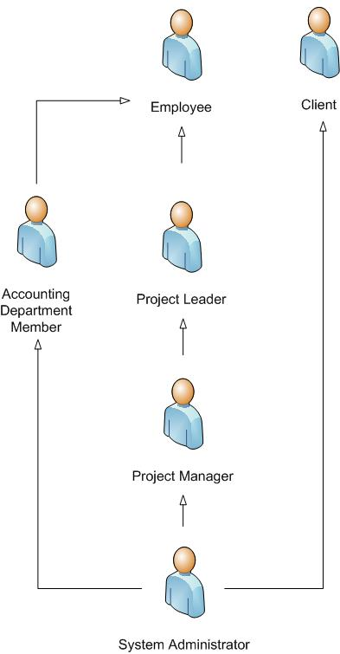
Figure 3
System roles and how they relate. (Note: All arrows indicate extensions of user types.)
Appendix C: Issues List
No issues have been identified.

